**LAB 3. ADO.NET AND REPORT**

**Exercise 1.** Given Internship Management database like the Lab 2:

* Students (student ID, full name, hometown, date of birth, GPA):
* Project (Project ID, Project name, Supervisor, funding)
* Student_Project (student ID, Project ID, internship place, distance, results)

**Requirements:**

1. **Design the Student search form and print preview as follows:**

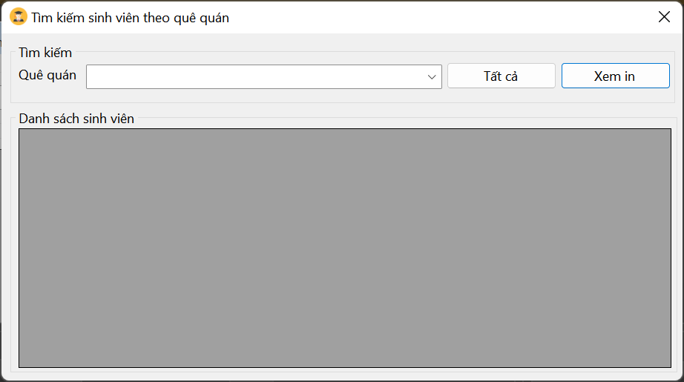

* Formload event:
  + “Hometown” combobox displays all the hometowns of existing students.
* When clicking on “Hometown” combobox:
  + Displays the students corresponding to the selected hometown.
* When “All” button is selected:
  + Show all students
* When the “Print PreView” button is pressed:
  + Display the form containing the Crystal Report control.
  + This control allows displaying student information by hometown
  + When the user presses “Printer icon” -> if there is a printer, the current student information will be printed

1. **Thiết kế form tìm kiếm và in ấn đề tài:**

* Theo Chủ nhiệm đề tài
* Theo Kinh phí đề tài (<= 10.000.00, <= 100.000.000, > 100.000.000)

1. Thiết kế form tìm kiếm và in ấn kết quả thực tập:

* Theo sinh viên
* Theo đề tài
* Theo chủ nhiệm đề tài

1. **Design the Project search form and print Preview form:**

* Search by the Superviser
* Search by the Project Funding (<= 10,000.00, <= 100,000,000, > 100,000,000)

1. **Design Internship results search form and print Preview:**

* Search by students
* Search
* Search by Superviser.